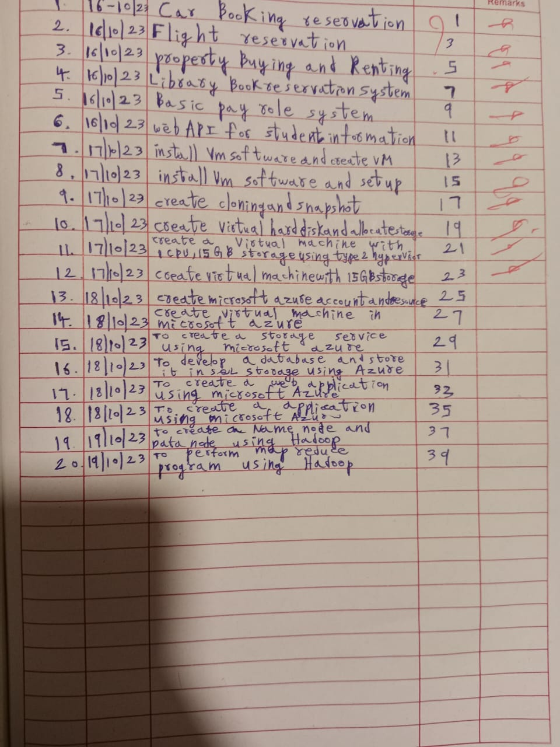

EXPERIMENT NO:13

13.To create a Microsoft azure account and resources

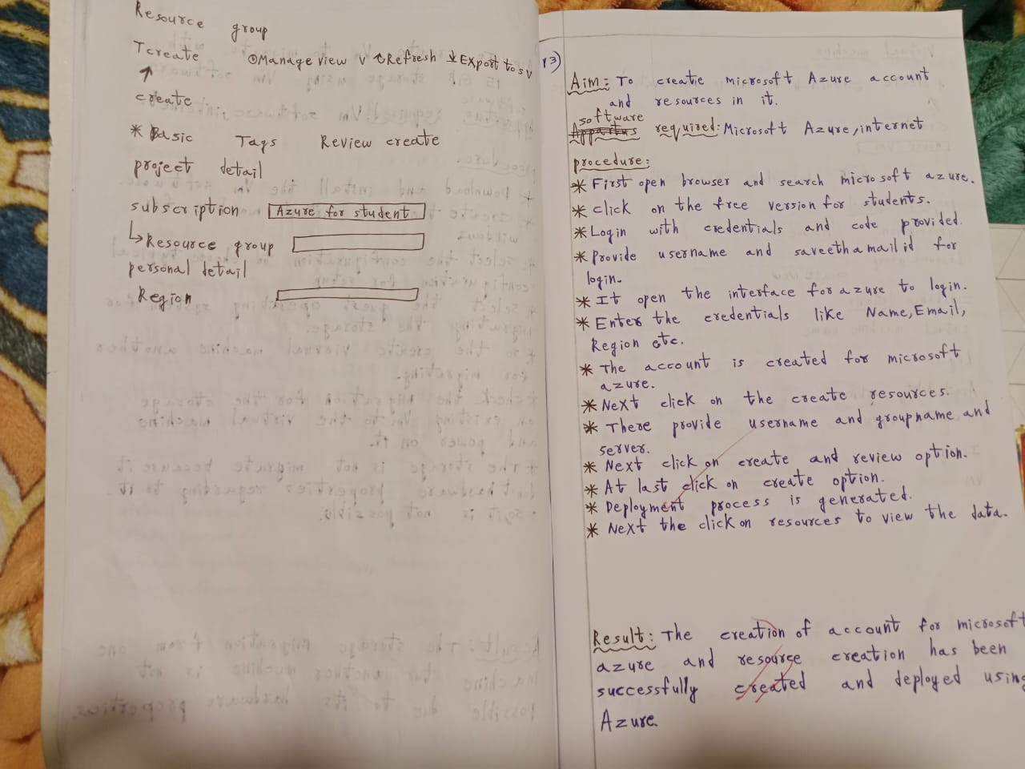

EXPERIMENT NO:14

14.To create a virtual machine in Microsoft azure

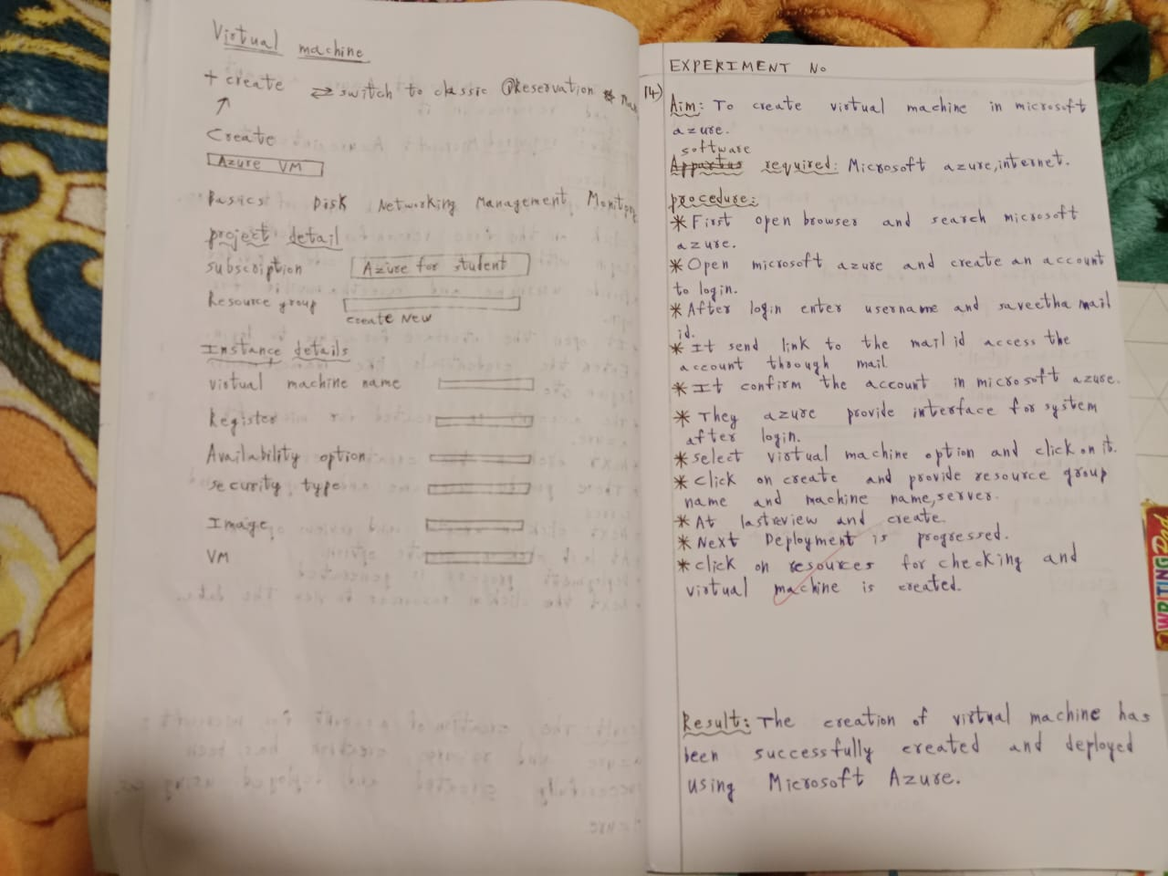

EXPERIMENT NO:15

15.To create a storage service using Microsoft azure

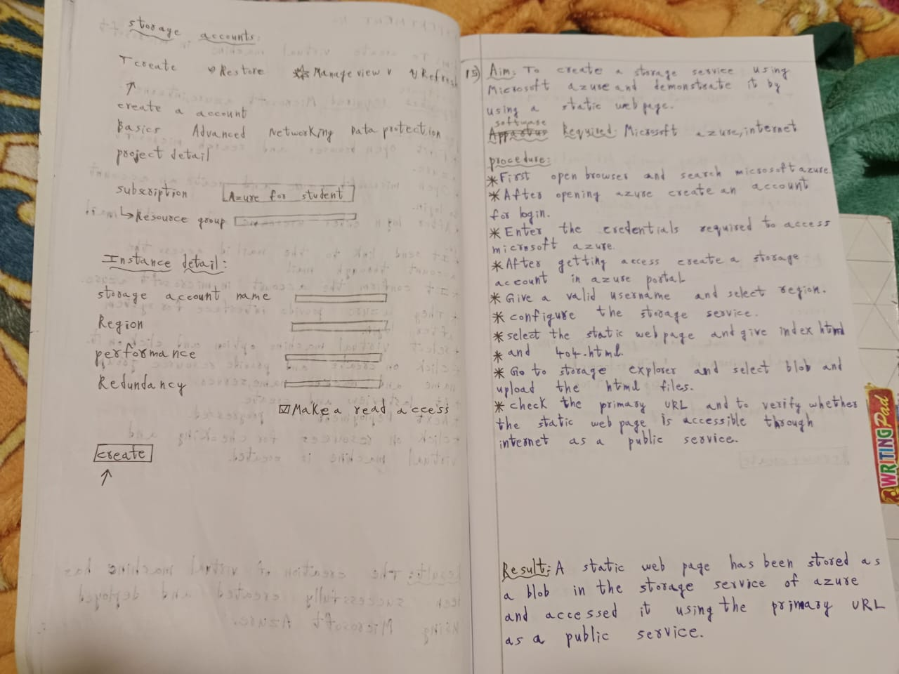

EXPERIMENT NO:16

16.To develop a database and store it in SQL storage using Microsoft azure

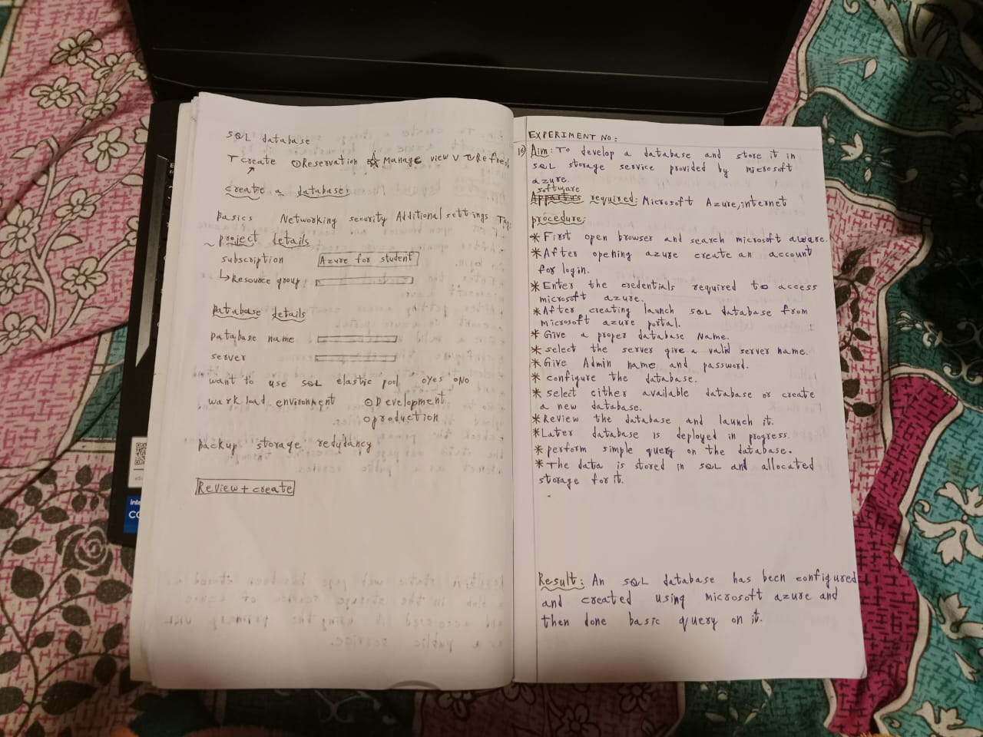

EXPERIMENT NO:17

17.To create a web application using Microsoft azure

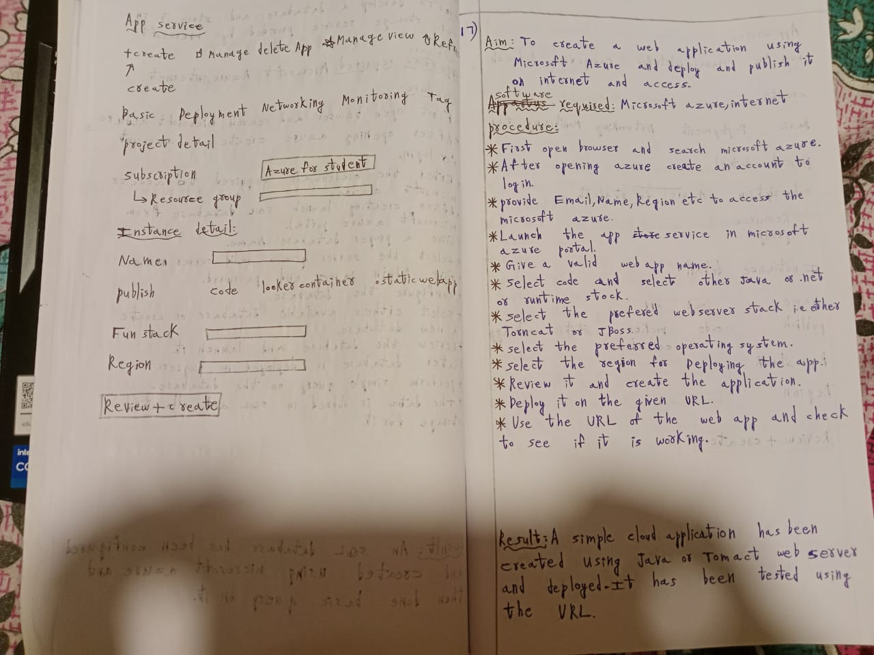

EXPERIMENT NO:18

18.To create an application using Microsoft azure

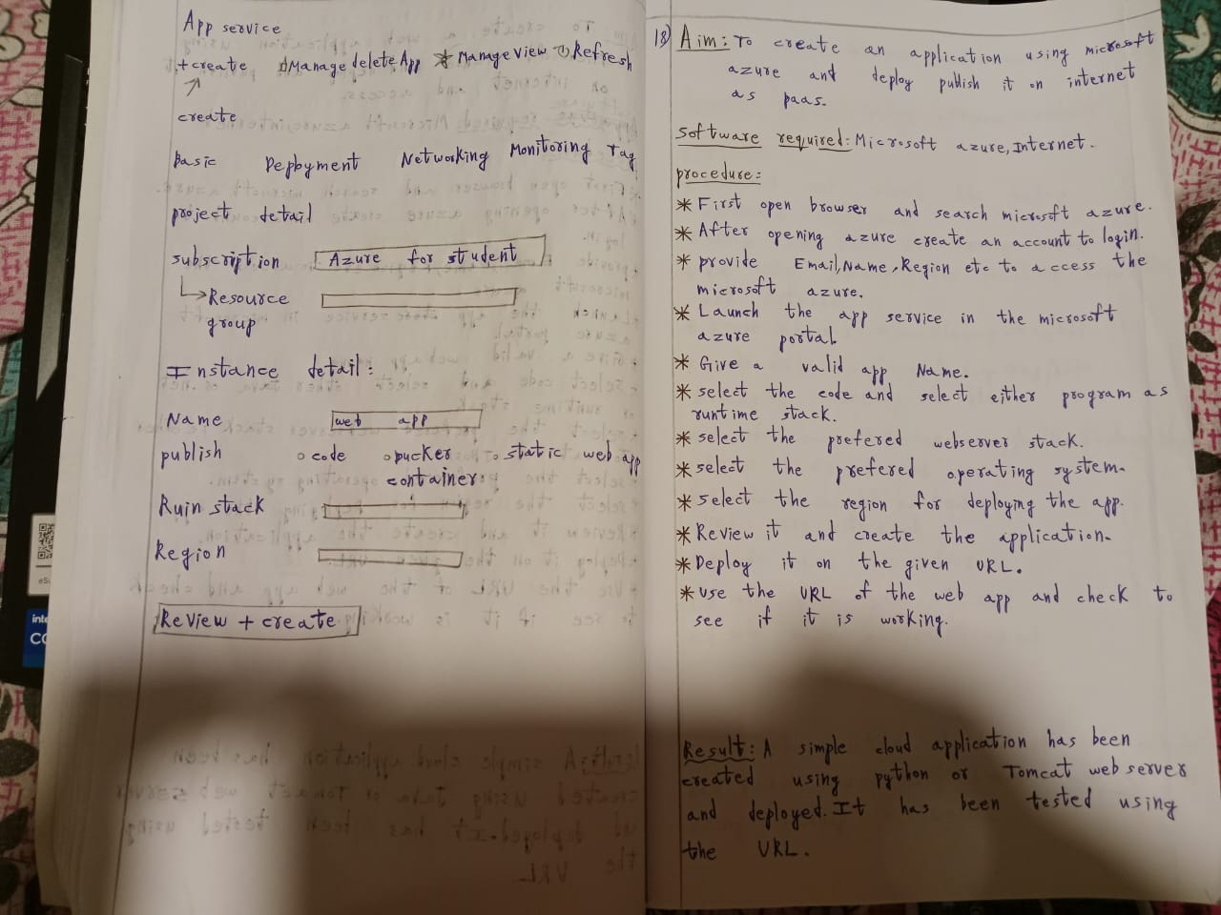

EXPERIMENT NO:19

19.To create a Data node and name node in Hadoop architecture

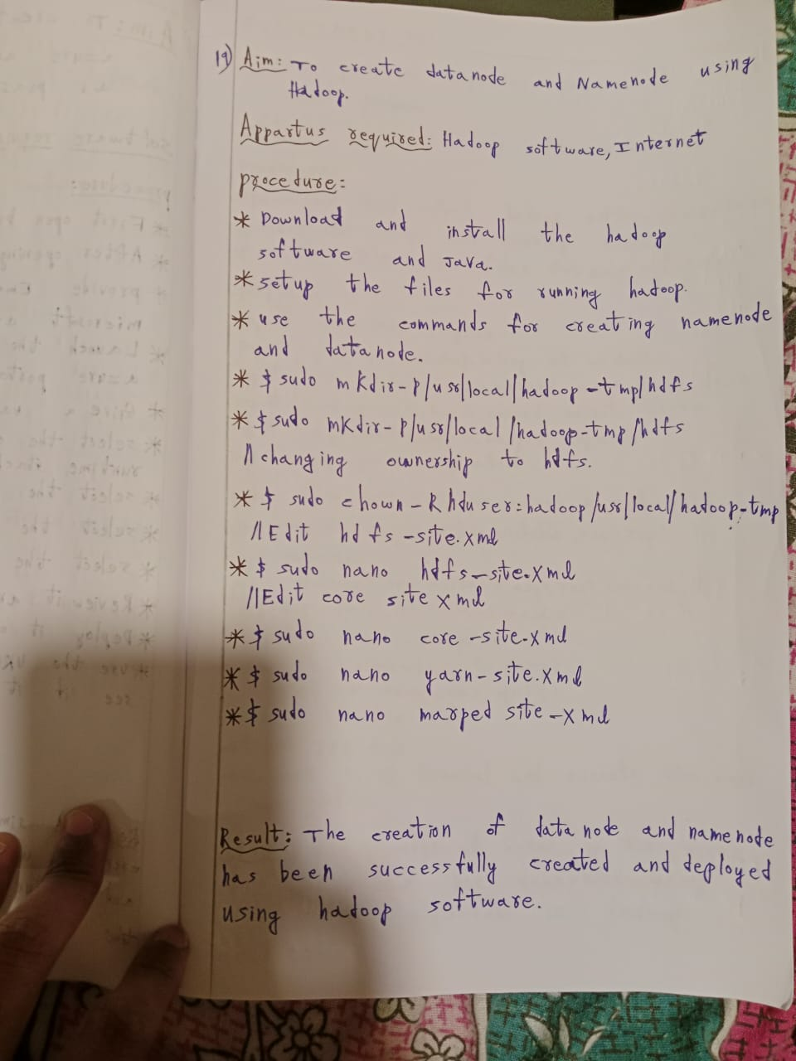

EXPERIMENT NO:20

20.To create a map reduce program in java using Hadoop

